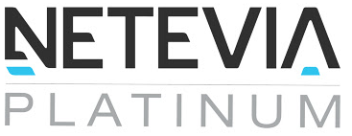

Addendum for Exclusive POS Solutions

This Addendum is for the Netevia Platinum Exclusive POS offer for Netevia Platinum Agents, ISO’s and W2 that are participating in our exclusive program. The Agreement is effective upon signature and date below and subject to change at any time in accordance with your original agreement on file with Netevia Platinum. The POS Solution will be a 50/50 split with your current schedule and will contain an activation bonus up to $1500.00 based on the current program volumes, the bonus can’t be combined with any other bonus within your original schedule. The activation bonus will be paid once your account has processed a minimum of $299.00. The bonus is subject to claw back within the first 12 months of processing if the customer should stop processing. An ETF will need to be in each agreement at the current retail value for the term of the program of 48 months.

IN WITNESS WHEREOF, the parties hereto have executed this Addendum Agreement as of the Effective Date. [Company Name] By: [Authorized Signatory] [Title]

[Employee Name] By: [Employee Signature] [Date]